Social Engineering Lab Report

1. Objective
To simulate social engineering attacks using OSINT tools and phishing techniques in a controlled lab environment.

2. Tools Used
- PhoneInfoga
- Maltego
- Social-Engineer Toolkit (SET)
- Python HTTP Server

3. Intel Gathering (PhoneInfoga)
PhoneInfoga was used to analyze the target phone number. No significant publicly available information was found, indicating limited OSINT exposure.

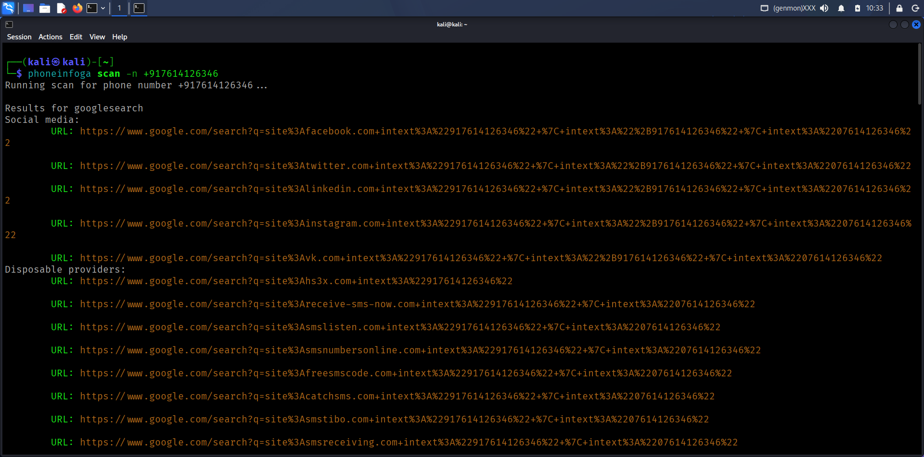

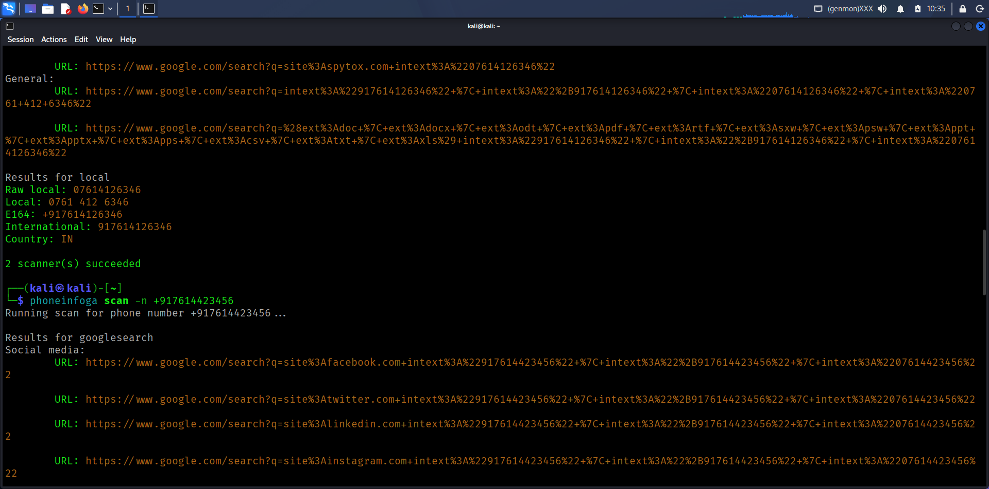

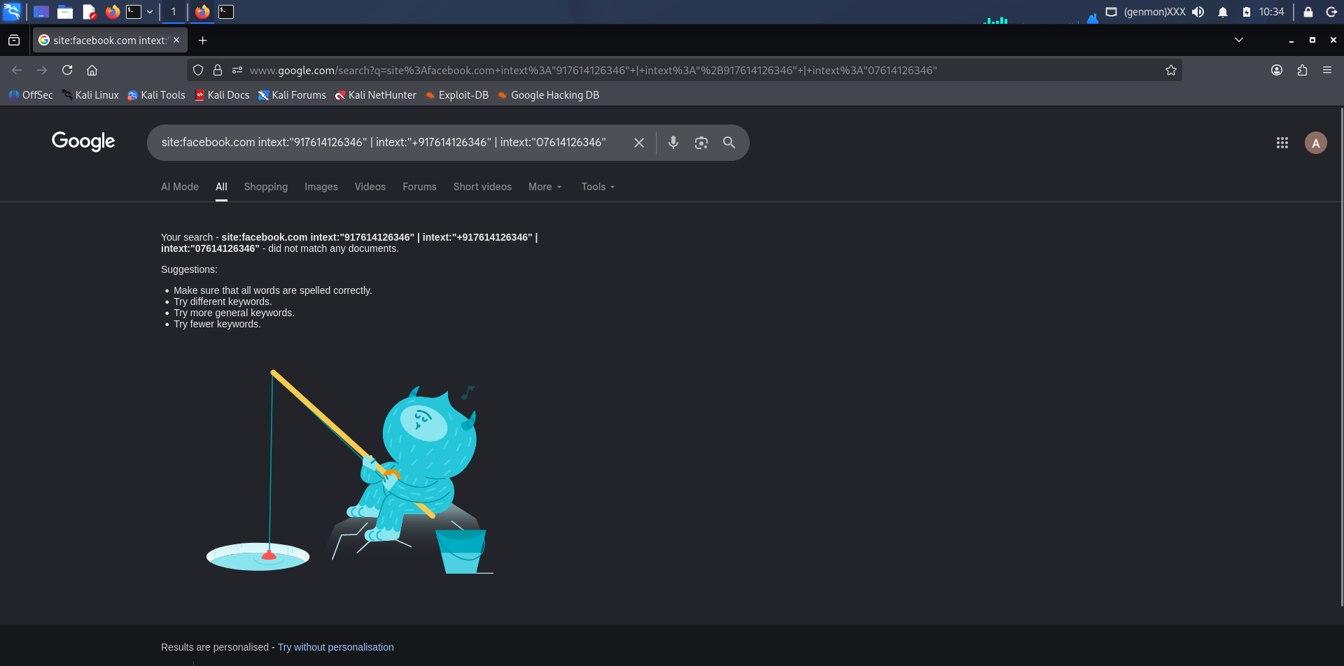

4. Relationship Mapping (Maltego)
Maltego was used to visualize relationships. The analysis showed the phone number is not disposable and not flagged as risky. This suggests the number is legitimate.

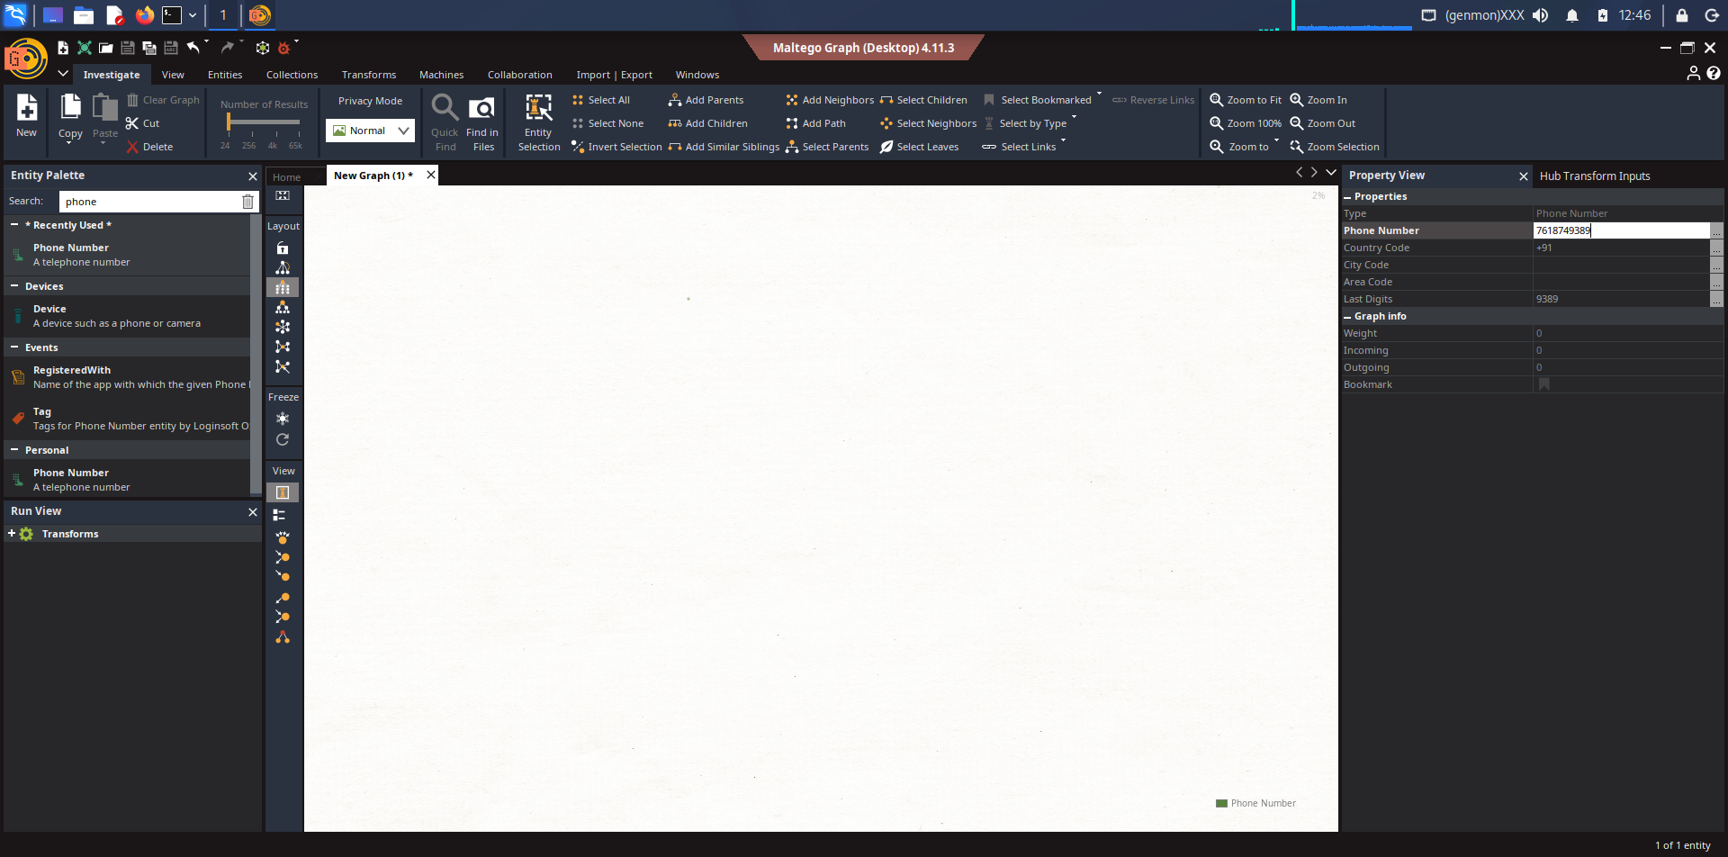

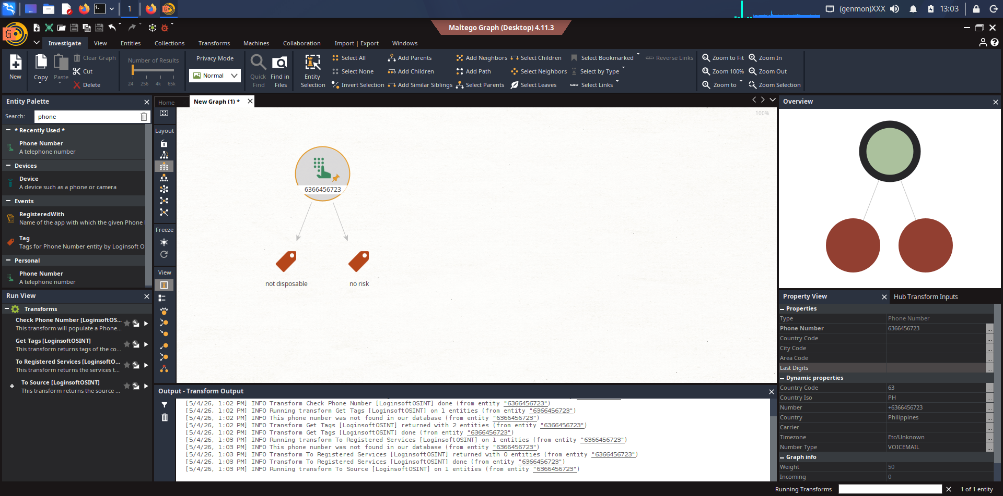

5. Phishing Simulation (SET)
SET was used to create a credential harvesting attack using a built-in web template. A phishing page was hosted locally, and test credentials were successfully captured.

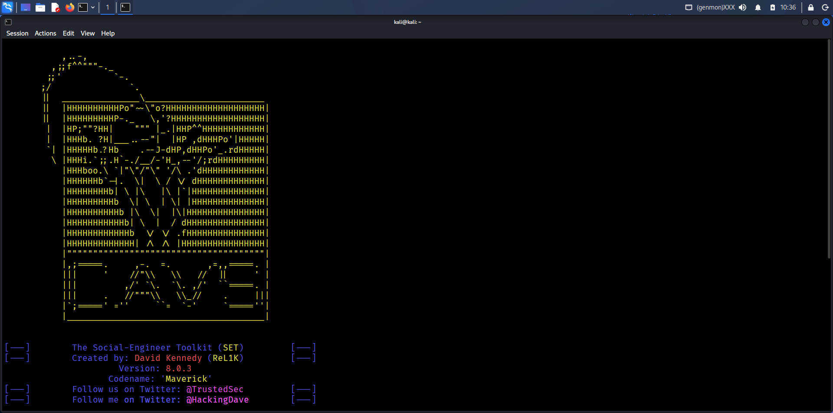

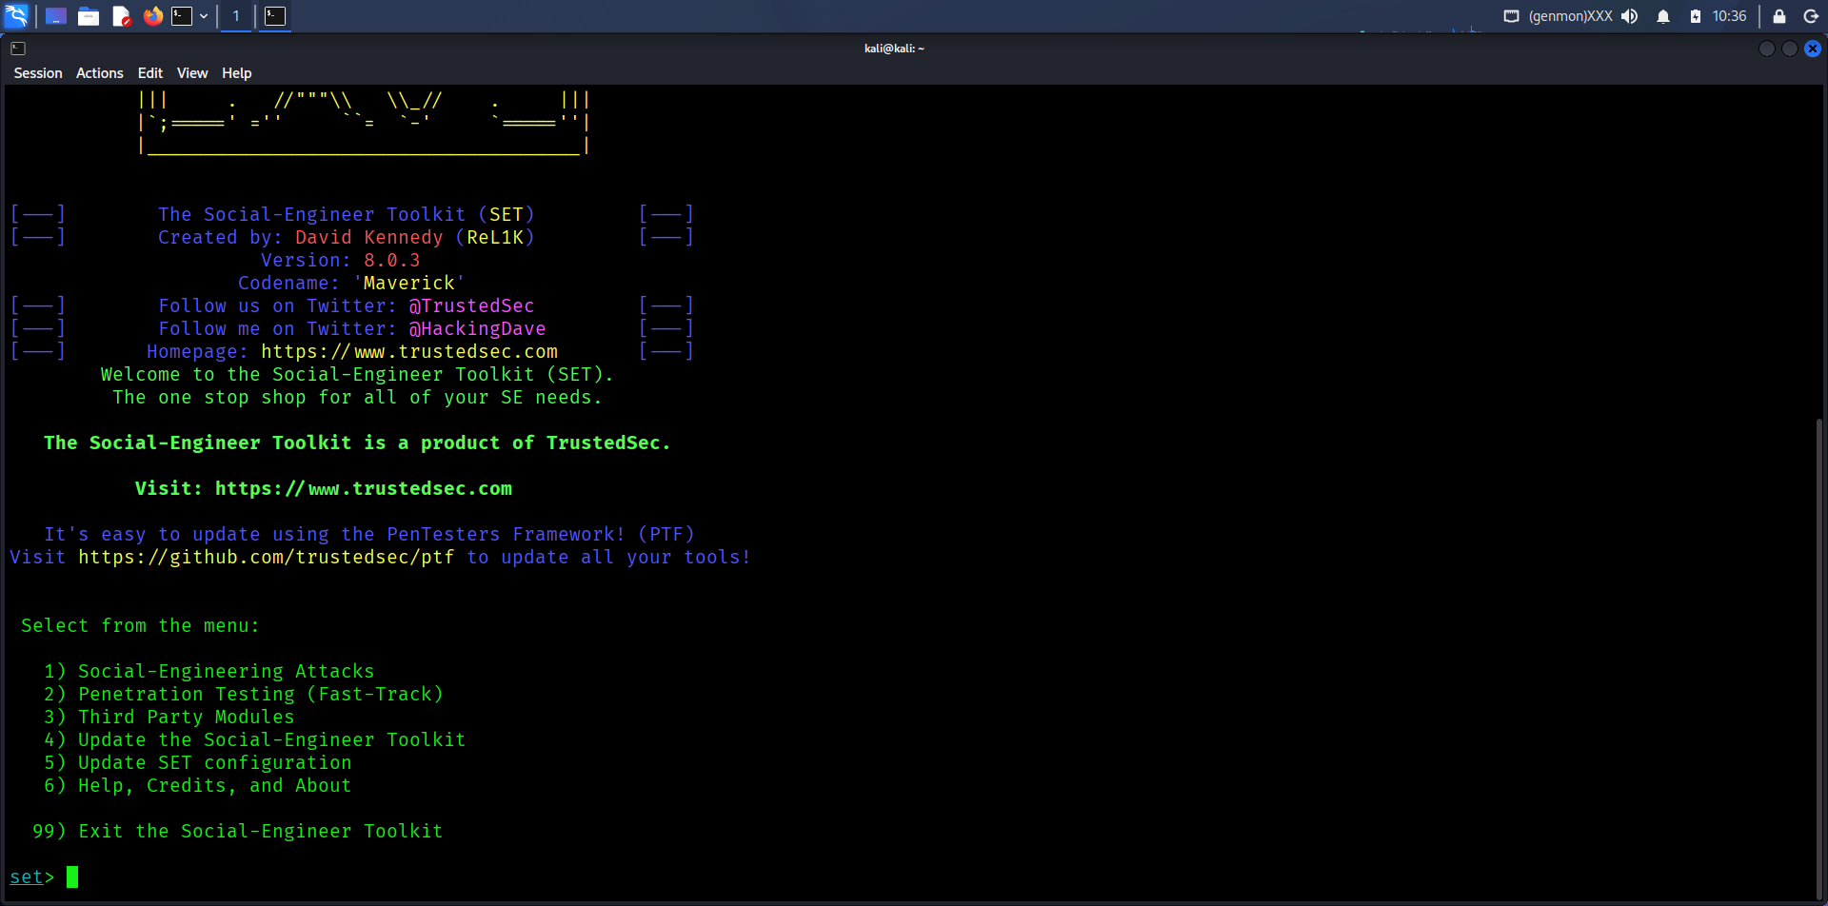

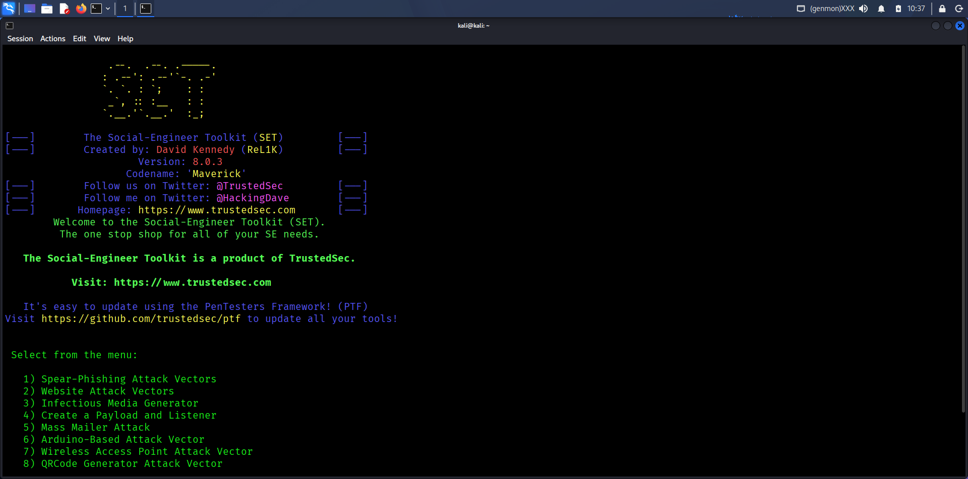

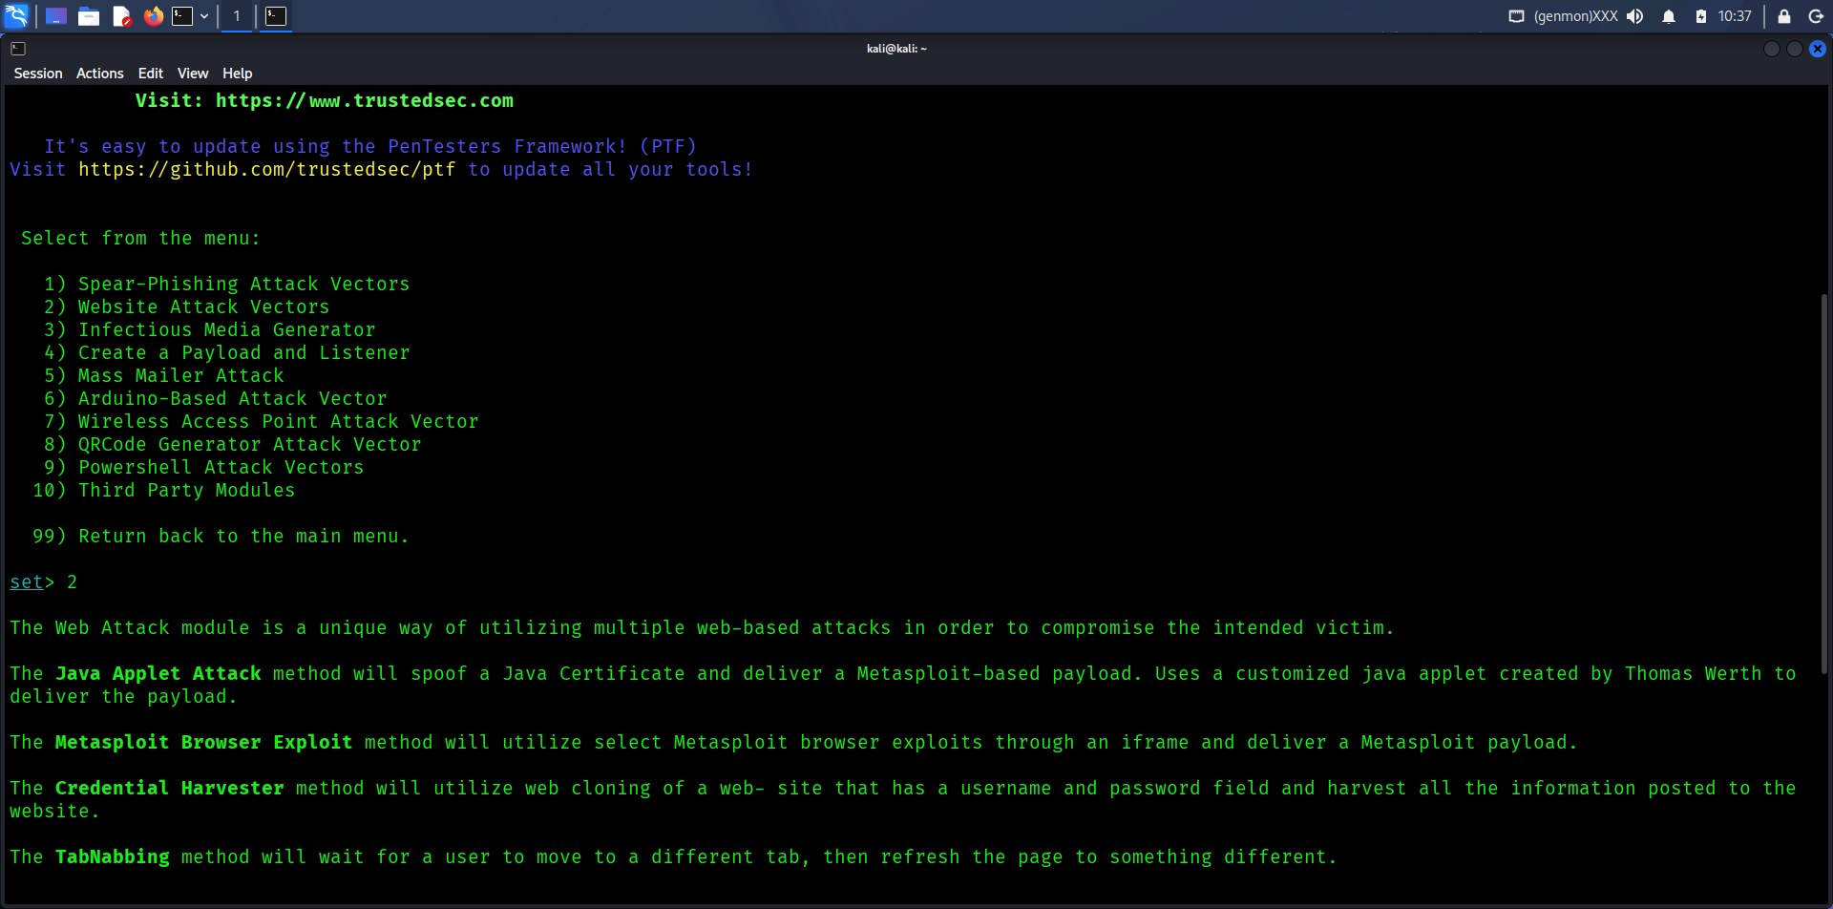

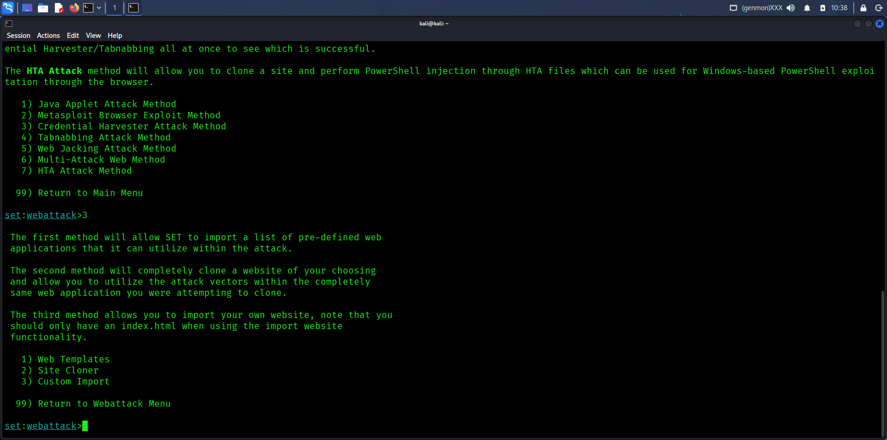

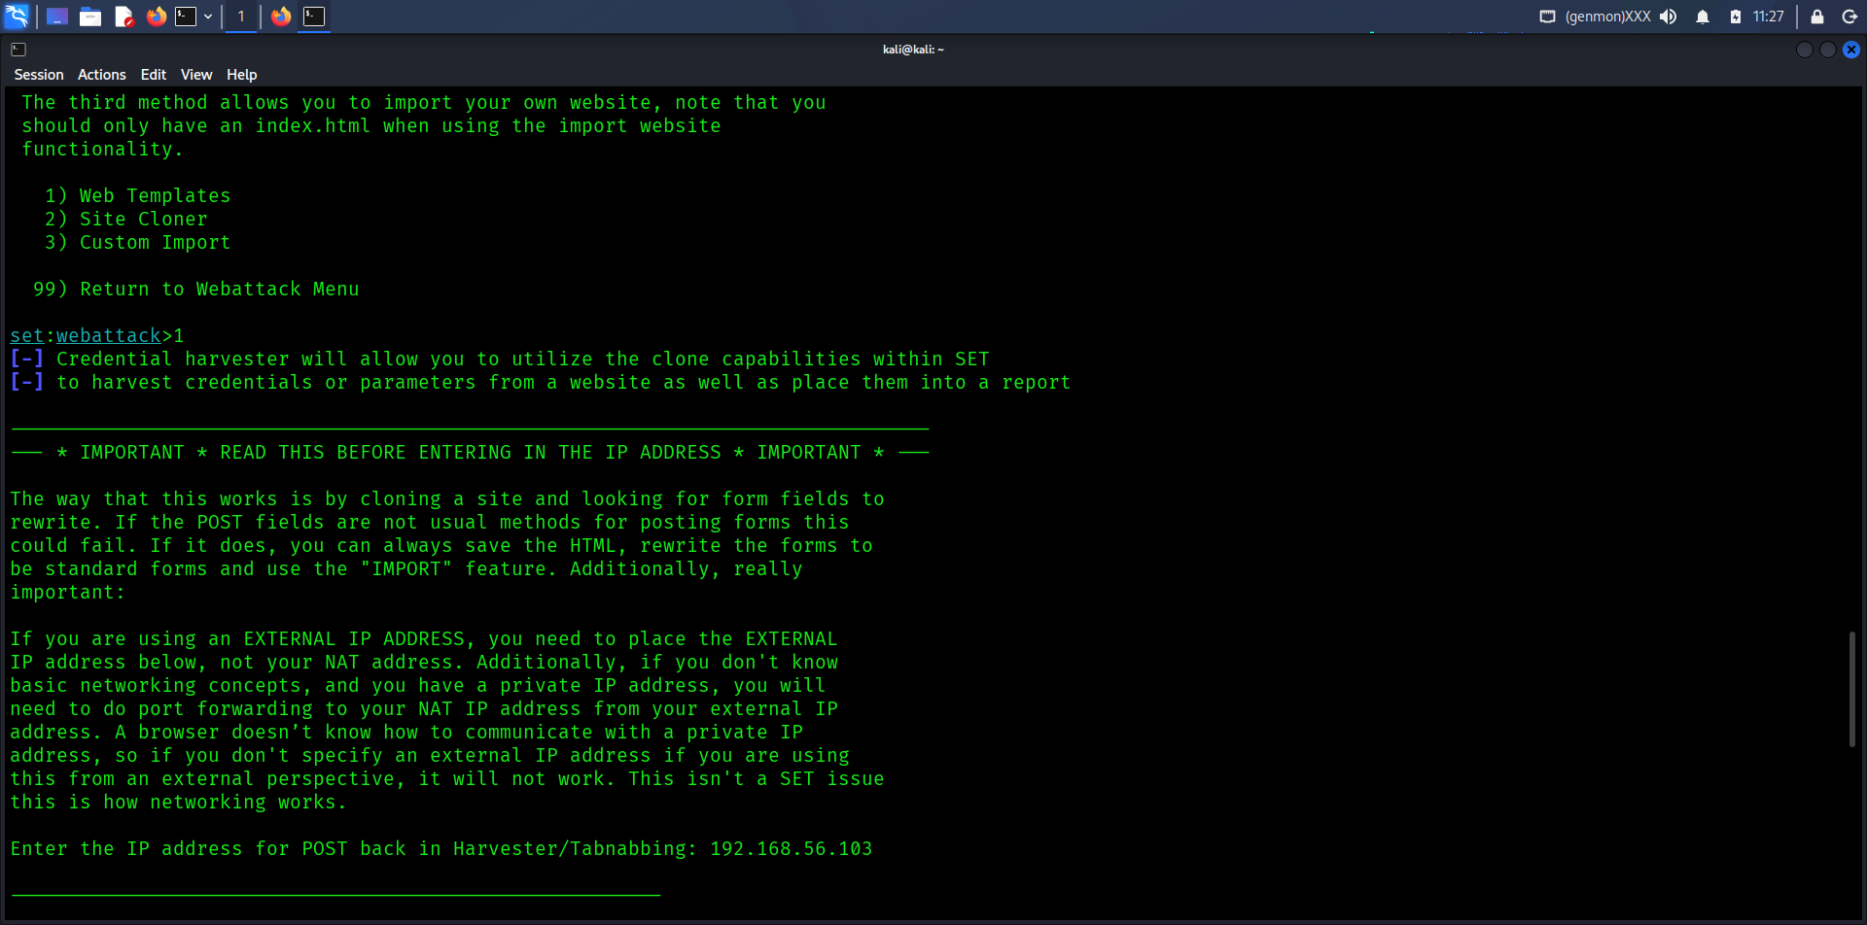

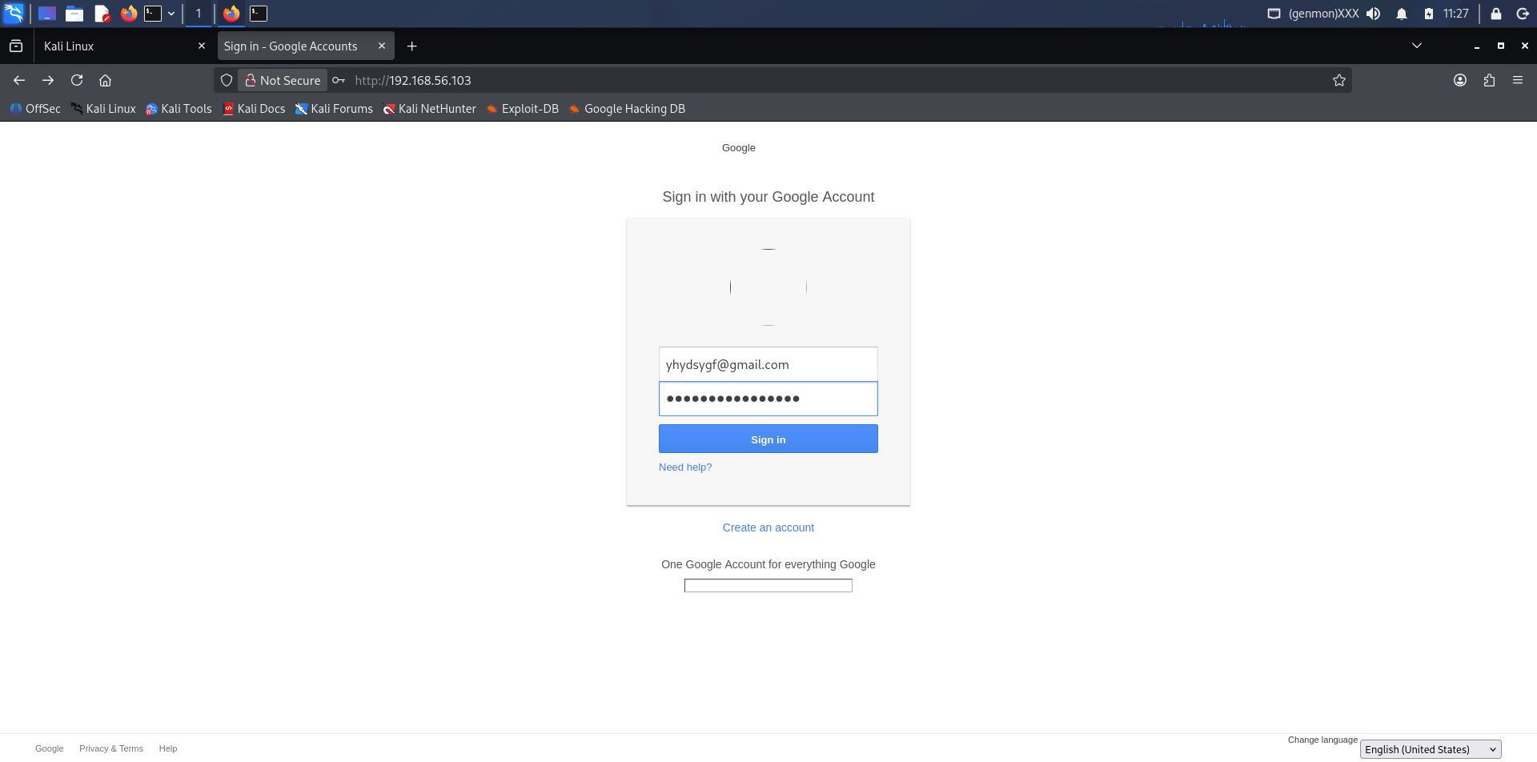

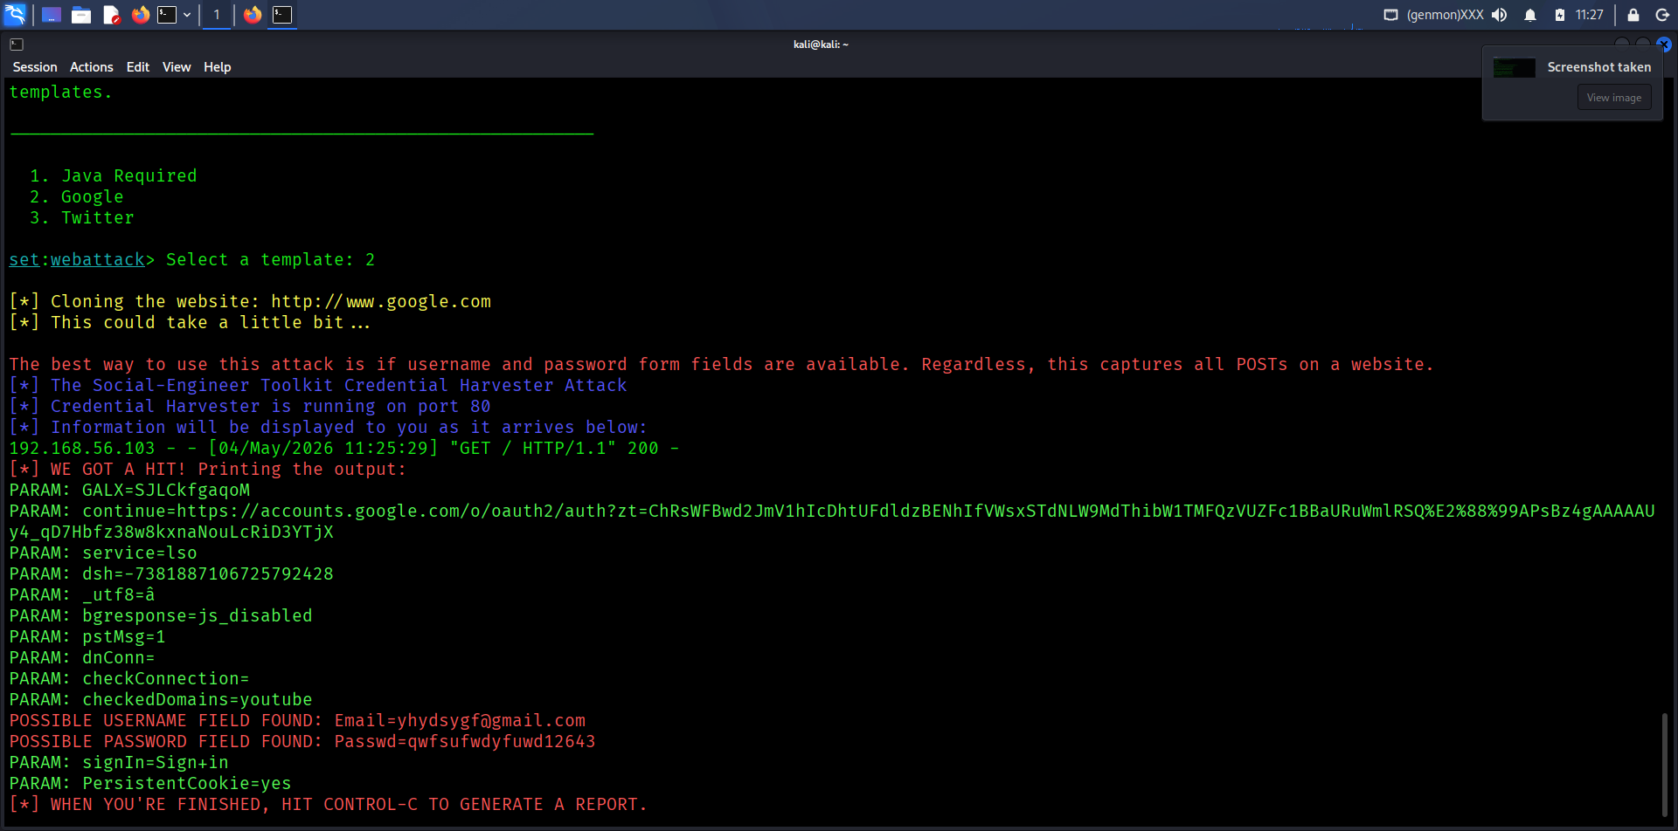

6. Vishing Scenario
An attacker impersonates IT support and asks the victim to visit a login page hosted by the attacker. The victim enters credentials, which are captured.

7. Results
Credential harvesting successful
OSINT data limited but valid
Maltego mapping completed

8. Conclusion

The lab demonstrated how social engineering attacks can be performed using OSINT and phishing techniques to gather sensitive information.

